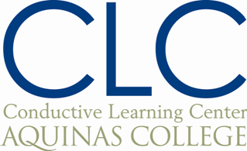

Aquinas College/IPI POHI Major
Task Analysis

Date: April 26, 2015
Name: Kelli Sprenger

Type of Program: Individual Program
Group: Lower Primary
Time: 1:15-2:10
Conductors/AQ students: None
Students: D.D., Z.W., and J.L.

Tools/Equipment: blue/red bench, ropes, ladder, rings, bean bags, boxes, sticks, cones, ball
Conductive education aims:
- Enjoy physical activities
- Develop balance when walking forwards and backwards
- Increase speed and accuracy of movements
- Step over obstacles of various heights
- Actively engage with one another to accomplish tasks

Motivation: Competing in a variety of activities

Schedule:
1:15-1:20 Transfer to room across the hall while playing “Red Light, Green Light”.
1:20-1:30 Explanation and demonstration of stations and transfers between stations
Station 1: Slalom race- Walk through a slalom obstacle course, maintaining upright, balanced position to keep a ring on top of head. Record how many times ring falls off.
Transfer 1: Stepping over elevated bars at various heights. (D.D. walks forwards, Z.W. and J.L. walk backwards)

Station 2: Bean bag toss- Stand behind designated line and toss bean bags into rings. Closest ring is worth 1 point, middle ring is worth 2 points, and farthest ring is worth 3 points. Record how many points are earned.

Transfer 2: Walk backwards on bench without support.

Station 3: Untie knots in a rope. If all knots are untied before the time is up, start tying new knots in the rope. Record how many knots are untied/tied.

Transfer 3: Walk through ladder elevated in the middle. (D.D. walks forwards, Z.W. and J.L. walk backwards)

1:30-2:00 Each child will be at their own station for two minutes, record their information on the sheet provided, reset the station, and transfer to the next station. Stations will be completed twice by each child.
2:00-2:10 Give feedback and appreciation. Transfer back to room by walking in a line and passing a ball to each other over the head.

